1.
Given a network address of 192.168.10.0/24, divide it into 4 equal subnets and write down the subnet mask, network address, and broadcast address for each subnet.

- Original network: 192.168.10.0/24 → 255.255.255.0
- Need 4 subnets → Borrow 2 bits → New mask = /26 → 255.255.255.192
- Each subnet has $2^{6}-2=62$usable hosts.

Subnet | Network Address | Broadcast Address | Usable Range
1 | 192.168.10.0 | 192.168.10.63 | 192.168.10.1 – 192.168.10.62
2 | 192.168.10.64 | 192.168.10.127 | 192.168.10.65 – 192.168.10.126
3 | 192.168.10.128 | 192.168.10.191 | 192.168.10.129 – 192.168.10.190
4 | 192.168.10.192 | 192.168.10.255 | 192.168.10.193 – 192.168.10.254

2.
For one of the subnets you created, assign valid IP addresses to 5 devices (such as a router, two laptops, a printer, and a mobile) and list which IP goes to which device.<br><br><em><strong>Hint:</strong> Make sure not to use the network or broadcast address for any device.</em>

Example subnet: 192.168.10.64/27
- Subnet mask: 255.255.255.224
- Network address: 192.168.10.64
- Valid host range: 192.168.10.65 – 192.168.10.94
- Broadcast address: 192.168.10.95

Device | Assigned IP address
Router | 192.168.10.65
Laptop 1 | 192.168.10.66
Laptop 2 | 192.168.10.67
Printer | 192.168.10.68
Mobile | 192.168.10.69

3.
Draw a simple diagram (hand-drawn or digital) showing your subnet plan: label each subnet, the range of IPs, and where each device is connected.
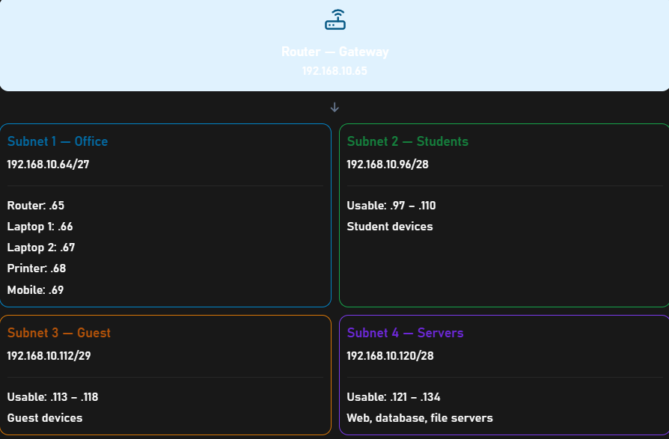

4.
Document step-by-step how you calculated the subnet mask, number of hosts per subnet, and assigned IP addresses for your plan, as if you are explaining it to a friend who is new to subnetting.

Step 1: Given Network

Network: 192.168.10.0/24
Default subnet mask: 255.255.255.0

Step 2: Calculate Subnet Mask and Hosts

CIDR | Subnet Mask | Total IPs | Usable Hosts
/27 | 255.255.255.224 | 32 | 30
/28 | 255.255.255.240 | 16 | 14
/29 | 255.255.255.248 | 8 | 6

Step 3: Subnet Plan

Subnet | Network Address | Usable Range | Broadcast
Office /27 | 192.168.10.64 | .65 – .94 | .95
Students /28 | 192.168.10.96 | .97 – .110 | .111
Guests /29 | 192.168.10.112 | .113 – .118 | .119
Servers /28 | 192.168.10.120 | .121 – .134 | .135

Step 4: Assign IP Addresses (Office)

Device | IP Address
Router | 192.168.10.65
Laptop 1 | 192.168.10.66
Laptop 2 | 192.168.10.67
Printer | 192.168.10.68
Mobile | 192.168.10.69

